Lecturer’s name: N/A | Date: Day 5
Course: Math 6 | Unit: Operations with Positive Fractions and Decimals
Unit Duration: 10 | Lesson Duration: 1 days
TEKS: 6.3ER | Lesson Part #1
Topic: Dividing Decimals Day 1

Lesson objectives:

I can represent mixed numbers and improper fractions on a number line.

I can write mixed numbers as improper fractions.

I can write improper fractions as mixed numbers.

Essential Questions:
- What is a mixed number?
- What is an improper fraction?
- How can I solve an improper fraction?
- How can I solve a mixed number?
- How are these 2 terms related to each other?

LYS Methodology
Be (Character/Values/Principles) - How does dividing values help me be more disciplined and dedicated?

Know (What resources are available to the student/ How can they use them) - Knowing and understanding the steps with division mathematically can help students understand the importance of resourcefulness, setting boundaries, and assertiveness

Do (Execute with Excellence) - Dividing values will help students be more driven while managing values and opportunities
Resources (Include Technology):
Instructional Input - Asynchronous
AS: Anticipatory Set (Introduction)
- Introduce the concept that a numerator can be greater than the denominator and this is called an IMPROPER FRACTION
- Introduce a mixed number and that is when there is a whole number + a fraction
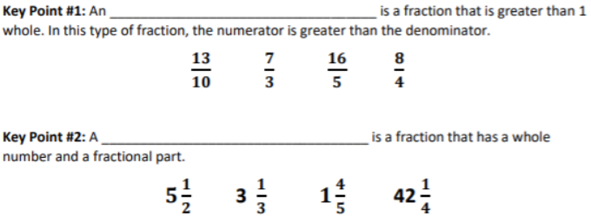
- **Invite students to give other examples and write those on the paper or board!!!

M: Modeling (I do)
- KP #3: Model HOW to convert an improper fraction to a mixed number by drawing a picture. Some example fractions are 13/5 or 8/3
- KP#4: Model HOW to convert an improper fraction to a mixed number by doing NIDO (numerator in, denominator out = LONG DIVISION)
  - Use the same examples as above: 13/5 or 8/3

GP: Guided Practice (We do)
- 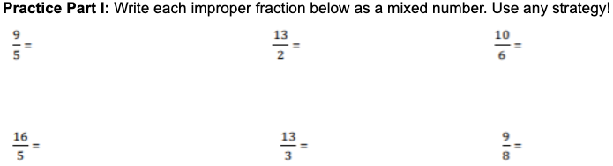

M #2: Modeling (I do)
- KP #5: Convert a mixed number into an improper fraction using TEXAS method
- 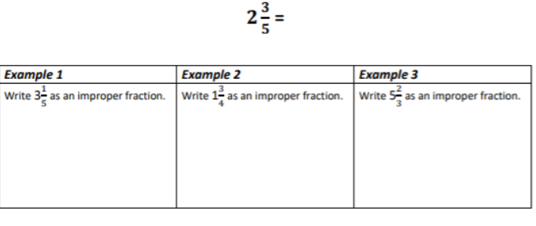

GP #2: Guided Practice (We do)
- Converting Mixed Numbers and Improper Fractions

High-Level Rigor Questions
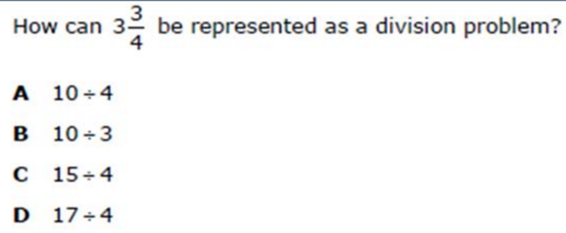

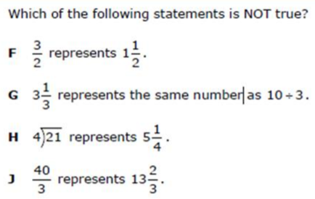

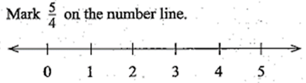

Instructional Input - Synchronous
AS: Anticipatory Set (Introduction)
- Introduce the concept that a numerator can be greater than the denominator and this is called an IMPROPER FRACTION
- Introduce a mixed number and that is when there is a whole number + a fraction

- **Invite students to give other examples and write those on the paper or board!!!

M: Modeling (I do)
- KP #3: Model HOW to convert an improper fraction to a mixed number by drawing a picture. Some example fractions are 13/5 or 8/3
- KP#4: Model HOW to convert an improper fraction to a mixed number by doing NIDO (numerator in, denominator out = LONG DIVISION)
  - Use the same examples as above: 13/5 or 8/3

GP: Guided Practice (We do)
- 

M #2: Modeling (I do)
- KP #5: Convert a mixed number into an improper fraction using TEXAS method
- 

GP #2: Guided Practice (We do)
- Converting Mixed Numbers and Improper Fractions

High-Level Rigor Questions






Independent Practice/ Homework
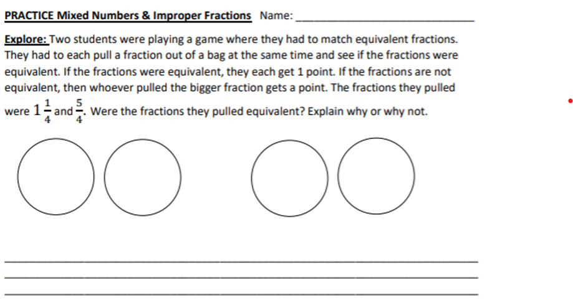

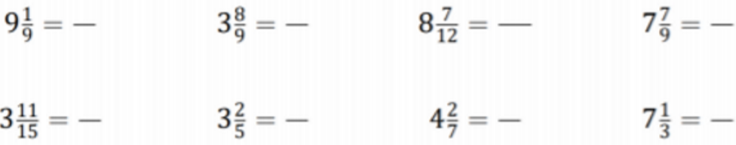

Lesson Close

Discipline is the bridge between goals and accomplishment - Jim Rohn

We use decimals everyday while dealing with money, weight, length etc. Decimal numbers are used in situations where more precision is required than the whole numbers can provide. For example, when we calculate our weight on the weighing machine, we do not always find the weight equal to a whole number on the scale.

